Yang Zhang Lab Practical

Problem 3:

(a):

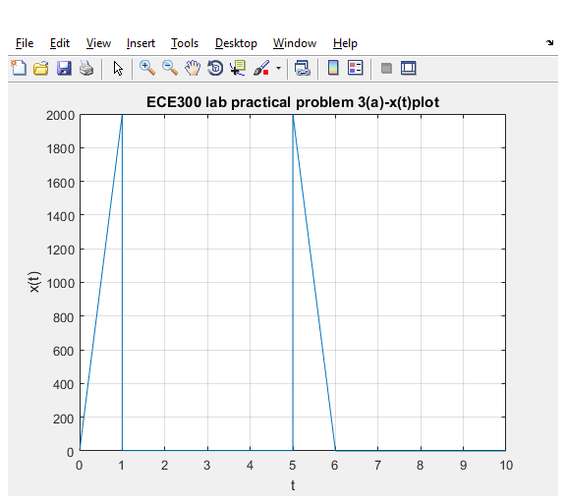

(b)

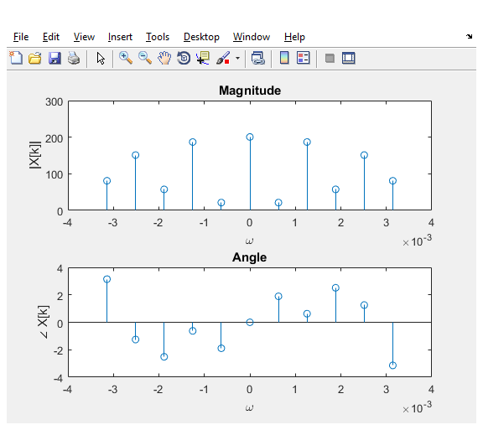

Code:

%Yang Zhang ECE300 Lab Practical

%Initial setup

clc;

clear;

%Plot x(t)

a = 0;

b = 10;

x = @(t) 2000\*t .\*(0<=t & t<1) + ...

2 .\*(1<=t & t<5) +...

-2000\*(t-6) .\*(5<=t & t<6)+...

0 .\*(6<=t & t<10);

M = 5000;

order = 5;

t = linspace(a, b, M);

figure(1);

plot(t,x(t)); grid;

xlabel('t');

ylabel('x(t)');

title('ECE300 lab practical problem 3(a)-x(t)plot');

% Find Fourier Series Coefficients

T0 = b-a;

w0 = 2\*pi/T0;

k= -order:order;

ck=1/M\*exp(-1i\*w0\*k'\*t)\*x(t) .';

ck = ck';

w = w0\*k;

% Plot ck

figure(2);

subplot(2,1,1);

stem(w\*10^(-3),abs(ck));

title('Magnitude');

xlabel('\omega');

ylabel('|X[k]|');

%

subplot(2,1,2);

stem(w\*10^(-3),angle(ck));

title('Angle');

xlabel('\omega');

ylabel('\angle X[k]');